**OBJECTIVE** **:**

***Our objective is to address the growing concern of electronic waste and plastic pollution. By recycling these materials, we can significantly reduce their impact on the environment and minimize the need for wood-based products. If we can successfully implement this initiative on a larger scale, we can effectively combat the issue of e-waste and plastic waste.***

**INTRODUCTION:**

E-waste refers to electronic equipment that is discarded by consumers. This can include devices with both working and non-working parts. Some components of e-waste may contain toxic materials, while others are non-toxic. Additionally, some parts may still be usable, while others require recycling.

To address the issue of e-waste, we employ a method that involves breaking down old devices into smaller parts. These components are then mixed with plastic waste. This approach is both responsible and eco-friendly, as it helps to reduce the harm inflicted on the environment. By recycling and repurposing electronic waste, we can contribute towards a more sustainable future.

**Why we choose this project:**

1. **Alternative of wood**
2. **Minimize the consumption of wooden materials and products.**
3. **E-waste and waste plastic would be reduced.**

**ABSTRACT OF THE PROJECT:**

The issue of e-waste as well as are, becoming an increasingly pressing problem on a global scale, posing a significant threat to the environment. Astonishingly, a staggering 85% of e-waste finds its way into landfills or is incinerated, resulting in the release of harmful toxins. Additionally, e-waste constitutes a substantial portion, accounting for 70%, of toxic waste. To compound matters, a mere 12.5% of e-waste undergoes recycling.

However, our project aims to tackle this matter head-on by focusing on the sustainable recycling of both e-waste and plastic waste. By harnessing discarded e-waste such as circuit boards and old LEDs, we transform them into a fine powder. This powder is then combined with melted plastic, effectively creating molds. Although the process may seem simple, its impact is substantial.

Our project relies on a variety of materials, including crushed circuit boards, old LEDs, plastic fragments, wires, and various electronic components like transistors and resistors. We also make use of waste plastics. By melting and blending all these materials together, we are able to produce new, practical products.

In essence, our project offers a solution that not only helps reduce the accumulation of e-waste but also repurposes it into something beneficial, all the while safeguarding the environment.

**Researches On E-Waste:**

***These boxes show interesting facts about e-waste:***

India comes under the 3rd position to generate and produce e-waste in the larger amount all over the world. The recycling percentage of India is very low. By making the samples and making it a new application, we can reduce the world's E-Waste which is toxic enough.





This graph shows the million metric tons of e-waste increasing year by year.

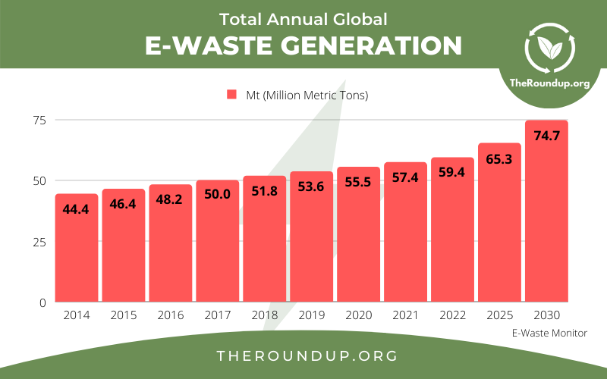

* It is estimated that 57.4 Mt (Million Metric Tons) of e-waste was generated globally in 2021.
* There has been an increase year on year since e-waste data started being collected in 2014.

India recycled only 32.9 percent of the e-waste generated in 2021-2022, data from the Ministry of Environment, Forest, and Climate Change shows. While the figure has gone up from previous years, it indicates that a staggering 10,74,024 tones (67%) of e-waste remained unprocessed.

* This pie chart shows that different types of metals and plastics, used in e-waste:  
  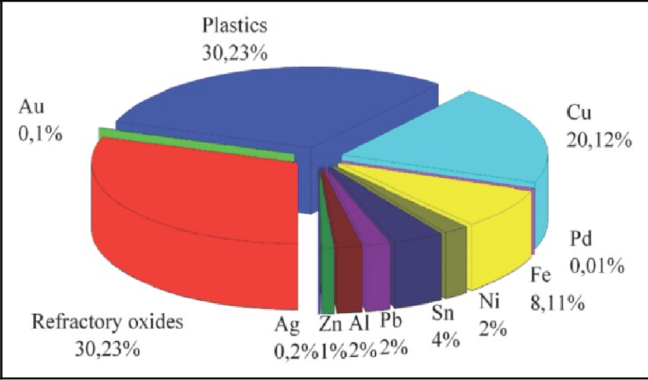Plastic = 30.23% Aluminum (Al) = 2%  
  Refractory oxides = 30.23% Zinc (Zn) = 1%  
  Copper (Cu) = 20.12% Silver (Ag) = 0.2%  
  Palladium (Pd) = 0.01% Gold (Au) = 0.1%  
  Iron (Fe) = 8.11%  
  Nickel (Ni) = 2%  
  Tin (Sn) = 4%  
  Lead (Pb) = 2%

**Materials Used In E-Waste**

Printed Circuit Boards (PCBs) are typically made using a laminate material as the base, which provides both mechanical support and electrical insulation. The most common material used for PCBs is a type of fiberglass-reinforced epoxy resin known as "FR-4." FR-4 is widely used because of its excellent electrical insulating properties, good mechanical strength, and relatively low cost.

The basic composition of an FR-4 PCB includes layers of fiberglass cloth impregnated with epoxy resin. Copper foil is then laminated onto one or both sides of the FR-4 material. The copper foil serves as the conductive pathway for the electrical connections on the board. The PCB manufacturing process involves etching away the unwanted copper to create the desired circuit patterns.

In addition to FR-4, there are other specialized PCB materials used for specific applications, such as high-frequency PCBs, flexible PCBs (made from materials like polyimide), and metal-core PCBs (where a metal core is used for better heat dissipation). The choice of PCB material depends on the specific requirements of the electronic device and its intended use.

**Types of Plastics Used in Our Products:**

* ***Thermoplastic:-***

Thermoplastic is versatile, used in various industries like medical, electronics, and packaging, for items like containers, clothing, and cable insulation, even replacing glass in some cases.

Some thermoplastics are environmentally friendly as they are easily recyclable. Thermoplastic can be reheated and reshaped, without losing its strength, and therefore can be reused again and again, making for a sustainable material and less plastic waste.

Thermoplastic manufacturing can result in lower energy consumption too since it often requires shorter production cycles.

* ***PolyPropylene:***Polypropylene (PP) is a tough, rigid, and crystalline thermoplastic. It is made from propene (or propylene) monomer. This linear hydrocarbon resin is the lightest polymer among all commodity plastics. PP comes either as a homopolymer or as a copolymer and can be greatly boosted with additives.

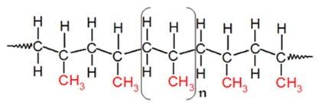

Polypropylene is a type of polyolefin that is roughly harder than polyethylene. It is a plastic with low density and high heat resistance. Its chemical formula is **( C3H6)n**

* Semi-rigid
* Translucent
* Good chemical resistance
* Tough
* Good fatigue resistance
* Integral hinge property
* Good heat resistance
* ***Polycarbonate:***

Polycarbonate (PC) is a transparent thermoplastic with carbonate functional groups. Its high strength makes it resistant to impact and fracture. It is lightweight and an excellent alternative to glass. The PC is melted and forced into a mold with high pressure to give it the desired shape. It is widely used owing to its eco-friendly processing and recyclability.

Polycarbonate is a high-performance tough, amorphous, and transparent thermoplastic polymer. It has organic functional groups linked together by carbonate groups (–O–(C=O)–O–). It offers a unique combination of properties. PC is popularly used as an engineering plastic owing to its unique features that include:

* High impact strength
* High dimensional stability
* Good electrical properties amongst others

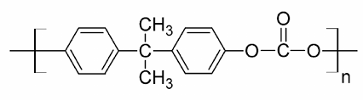

* Its properties are:
* Toughness – Polycarbonate maintains a [toughness](https://omnexus.specialchem.com/polymer-properties/properties/toughness?src=sg-overview-cnx) value between -20°C to 140°C.
* High Impact Strength – PC has a high strength that makes it resistant to impact and fracture. It provides safety and comfort in applications that demand high reliability and performance.
* Transmittance – PC is an extremely clear plastic that can [transmit over 90% of light](https://omnexus.specialchem.com/polymer-properties/properties/transparency?src=sg-overview-cnx) as good as glass. Polycarbonate sheets are available in a wide range of shades. These sheets can be customizable depending on an end-user application.
* Lightweight – This feature allows virtually unlimited possibilities for OEMs to design as compared with glass. The property increases efficiency and makes the installation process easier. It also reduces overall transportation costs.
* Chemical Resistance – [Good chemical resistance](https://omnexus.specialchem.com/selectors/kf-chemical-resistance-good/c-thermoplastics-pc-polycarbonate?src=sg-overview-cnx) against diluted acids, aliphatic hydrocarbons, and alcohols. It shows moderate resistance against oils and greases. PC is readily attacked by diluted alkalis, aromatic, and halogenated hydrocarbons. Manufacturers recommend cleaning PC using agents which do not affect their chemical nature. It is sensitive to abrasive alkaline cleaners.
* Heat Resistance – Polycarbonates have [high heat resistance](https://omnexus.specialchem.com/selectors/kf-heat-resistance-high/c-thermoplastics-pc-polycarbonate?src=sg-overview-cnx). They are thermally stable up to 135°C. Further heat resistance can be improved by adding flame retardants without impacting material properties.
* ***Polyethylene:***

Polyethylene (PE) is one of the most popular thermoplastic materials. It is available in different crystalline structures, referred to as HDPE, LDPE, and LLDPE. This commodity plastic is produced by addition or radical polymerization. It is used in a large array of applications: plastic containers, bottles, bags, plastic toys, etc.

Polyethylene or polythene is a type of polyolefin. It is often abbreviated as PE. The chemical formula of PE is (C2H4)n. It is lightweight, durable, and one of the most commonly produced plastics. Used for frozen food bags, bottles, cereal liners, yogurt containers, etc.

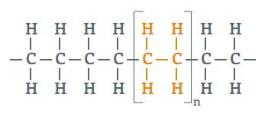

There are also two other types of plastics in **PE**:

* HDPE - High Density Polyethylene:[High Density Polyethylene (HDPE)](https://omnexus.specialchem.com/selectors/c-thermoplastics-pe-polyethylene-hdpe?src=sg-overview-cnx) is a cost-effective thermoplastic with a linear structure. It has no or low degree of branching. It is flexible, translucent/waxy, and weather resistant. The chemical structure of HDPE is:

Molecular Structure of HDPE

**HDPE Molecular Structure**

* LDPE - Low Density Polyethylene:[Low-density Polyethylene (LDPE)](https://omnexus.specialchem.com/selectors/c-thermoplastics-pe-polyethylene-ldpe?src=sg-overview-cnx) is a semi-rigid polymer with low crystallinity (~50-60%). The LDPE is composed of 4,000-40,000 carbon atoms, with many short branches. Compared to HDPE, it has a higher degree of short and long side-chain branching. The chemical structure of LDPE is:

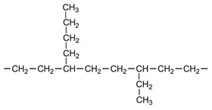

**LDPE Structure**

**The Procedure:**

**Collection of E-Waste Components:**

Our process begins with the collection of several types of electronic waste (E-waste) components, including Printed Circuit Boards (PCBs), LEDs, electrical wires, resistors, transistors, and even CDs. These components are carefully gathered and sorted.

**Component Size Reduction:**

To prepare these E-waste components for recycling, we take each type and cut them into smaller, more manageable pieces. This initial size reduction makes it easier to work with the materials and ensures a uniform mixture.

**Maceration with a Hand-Powered Grinder:**

Once the components are cut into smaller sizes, we move on to the maceration step. This involves using a hand-powered grinder to further reduce the size of these E-waste components. This meticulous process transforms them into a finely powdered form.

**Creating the Mixture with Plastic:**

With the powdered E-waste in hand, we proceed to create a mixture by adding carefully measured ratios of plastic. This step is crucial for achieving the desired consistency and properties in the final product. The plastic acts as a binding agent, helping to transform the powdered E-waste into a solid, cohesive form.

*\*The decision not to separate certain metals from e-waste is based on practicality and efficiency. Separating large parts from e-waste makes the solid heavier and increases binding time during melting. We use magnets to separate big parts, but for components soldered or mixed with PCBs, separating them would be time-consuming and complex. This approach results in stronger materials, and we send the remaining large metal pieces to metal recycling companies.*

**Utilizing Waste Plastic as Binder:**

Our choice to use waste plastic as the binder in this mixture is not only resourceful but also environmentally responsible. By repurposing waste plastic as a binder, we contribute to reducing plastic pollution while simultaneously addressing the E-waste problem.

*For making samples and testing we have used “****PP - Polypropylene****” and “****PLA – Polylactic Acid”****.*

**Polypropylene (PP):  
 Strength – 27MPa  
 Melting point – 160 to 166 o C**

**Polylactic Acid (PLA):**

**Strength – around 40 MPa  
 Melting point – 150 to 160 o C**

**But on a large scale we can use a wider variety of plastic.**

| **Types of Plastics** | **Strength** | **Melting Point** |
| --- | --- | --- |
| **Polyethylene (PE)** | **30MPa** | **110-135°C** |
| **Polycarbonate (PC)** | **60MPa** | **155°C** |
| **High - Density Polyethylene (HDPE)** | **38MPa(approx)** | **248-266°C** |

These are the plastics that we can use on a large scale.

**Solidification into a Durable Form:**

The mixture, now combined with the waste plastic binder, is carefully processed to solidify it into a sturdy, hard form. This transformation ensures that the resulting product is both robust and capable of serving its intended purpose effectively.

**WHY RECYCLING MATTERS:*****On average, the total weight of global EEE (Electrical and Electronic Equipment) consumption increases annually by 2.5 million metric tons (Mt). Also 300 million computers and 1 billion cell phones go into production annually. It is expected to grow by 8% per year.***

***To reduce this recycling matters a lot.***

**Method of disposing E-waste done till now:**

Following methods are used to dispose e-waste till now:

* **Landfills**: E-waste is often buried in landfills, but this is harmful because it can release toxic substances into the soil and water.
* **Incineration**: E-waste is sometimes burned to reduce its volume, but this can release harmful gasses into the environment.
* **Acid Bath**: E-waste is soaked in acid solutions to recover metals, but the disposal of these acids can harm water resources.

***While some e-waste disposal methods have pros and cons, it's vital to know there are greener options. Unrecycled e-waste worsens plastic recycling and environmental issues. As we get from the data, 85% of e-waste is burned, harming the environment. In this way, our project not only recycles materials but also reduces the amount of e-waste going to big landfills to be burned.***

**Estimated Cost:**

**Glossary:** Here is a glossary of terms related to the process:

1. E-Waste (Electronic Waste): Discarded electronic devices or components, often containing hazardous materials that require special handling and disposal.

2. PCBs (Printed Circuit Boards): Flat boards that hold electronic components and connect them through copper pathways. They often contain hazardous materials such as lead and mercury.

3. Crushing: The process of reducing E-Waste materials, especially PCBs, into smaller pieces or particles for further processing.

4. Disbanding: The act of separating different materials (metals and plastics) within the crushed E-Waste for individual processing.

5. Melting: The application of high heat to transform plastic materials into a molten state, often necessary for reshaping or combining with other materials.

6. High Flame: An intense and controlled source of fire used for melting plastic. It can be a specific type of burner or torch.

7. Contaminated Plastic: Plastic that has been exposed to hazardous substances or chemicals, making it unsafe for direct handling or use without proper precautions.

8. Binding Form: Achieving a cohesive and solid state in which the crushed E-Waste and melted plastic are combined to form a single entity.

9. Sample: A representative portion or specimen of the E-Waste and plastic mixture, often taken for analysis or further testing.

10. Shaping: The process of molding or forming the E-Waste and plastic mixture into a desired shape or structure.

11. Observance: The final product or object resulting from the process, which may resemble a rock in appearance but is fundamentally different due to its composition and origin.